Name:- Shreyash Patil

PRN:- 22510039

Batch:- T3

Distributed db using cassandra in dockerized environment:

Setup:

1. Install docker engine on all the required PCs
2. Install the official docker image for cassandra database
   1. Command- `docker pull cassandra:latest`
   2. 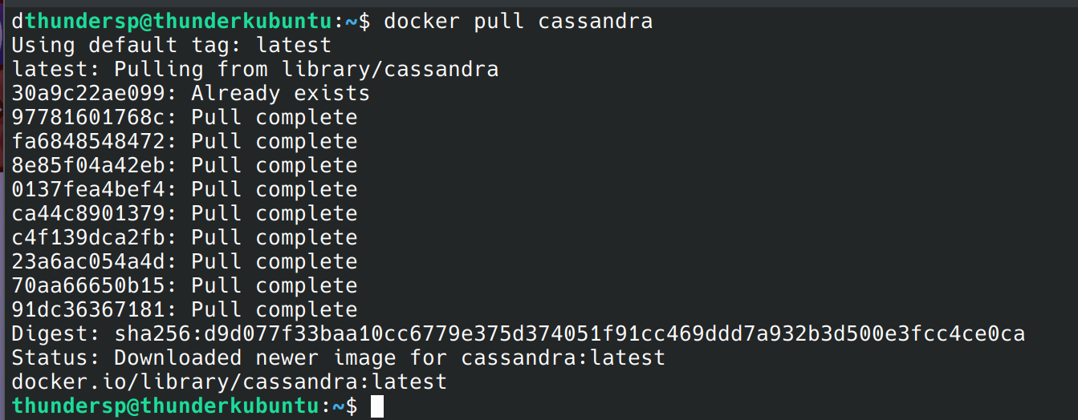
3. Note down the IPs of all the PCs in the network, make sure they are on the same network.
   1. 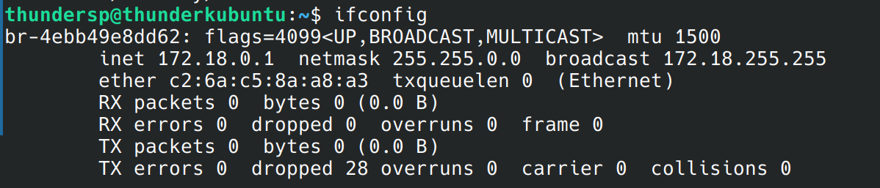
   2. 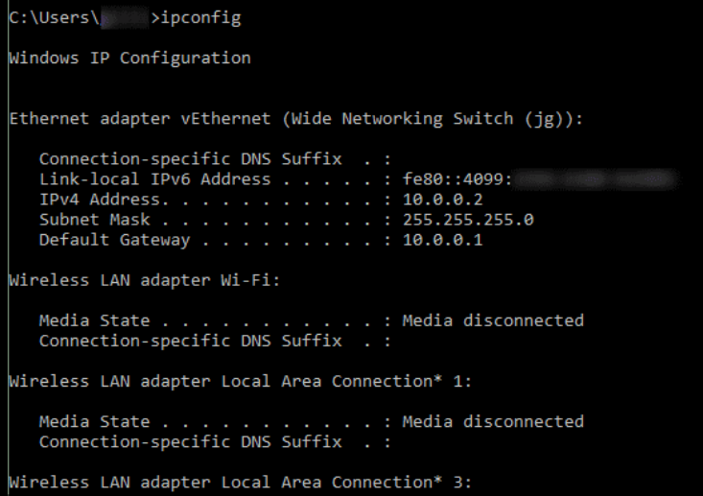
4. 1 node needs to be assigned as the cassandra seed node, where the PCs of other connect as a common point, pick one IP to do the same.
5. Run the following commands:
   1. On the Seed node:
      1. `docker run -d --name cassandra-seed -e CASSANDRA_CLUSTER_NAME="TestCluster" -e CASSANDRA_BROADCAST_ADDRESS=192.168.248.154  
          -e CASSANDRA_LISTEN_ADDRESS=192.168.248.154 -e CASSANDRA_RPC_ADDRESS=0.0.0.0 -p 7000:7000 -p 9042:9042 cassandra:latest`
   2. For other nodes:
      1. `docker run -d --name cassandra-node2 -e CASSANDRA_CLUSTER_NAME="TestCluster" -e CASSANDRA_SEEDS=192.168.248.154 -e CASSA  
         NDRA_BROADCAST_ADDRESS=192.168.248.104 -e CASSANDRA_LISTEN_ADDRESS=192.168.248.104 -e CASSANDRA_RPC_ADDRESS=0.0.0.0 -p 7000:7000 -p 9042:9042 cassandra:latest`
6. Through docker, start the container using docker start, watch the logs by `docker logs –f <container-name>`.
7. To enter the container use command:
   1. `docker exec –it cassandra-seed cqlsh`
8. On other terminal, use command `docker exec -it cassandra-seed nodetool status` to get the list of all the nodes which are currently connected to the cluster and their status.
   1. 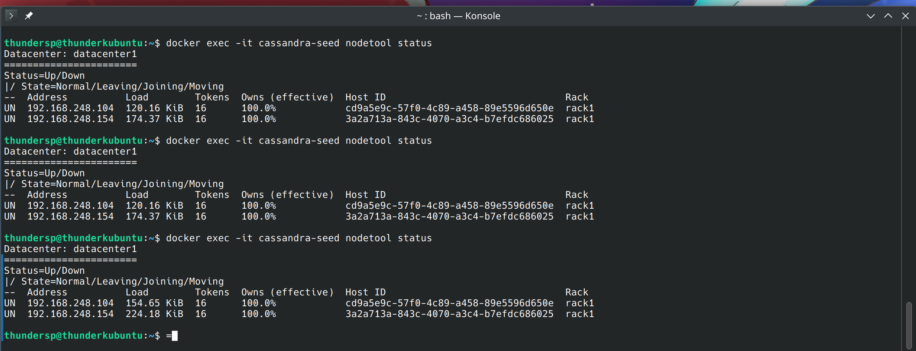
9. Once all the PCs show up in the cassandra Cluster, we can run commands in the cql lang to create and update database from any of the nodes:
   1. 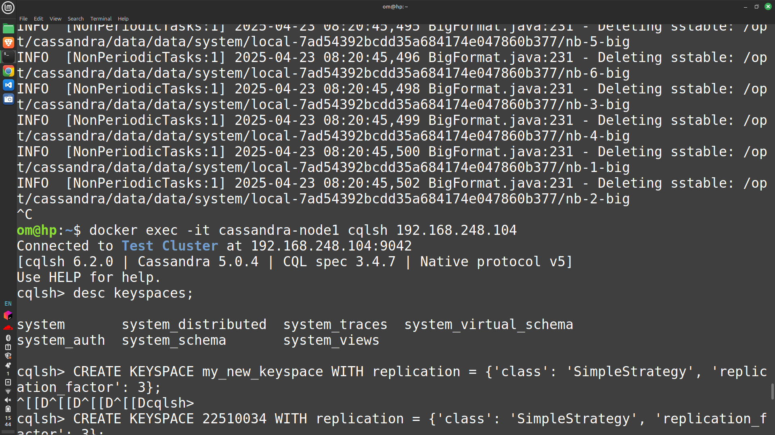
   2. 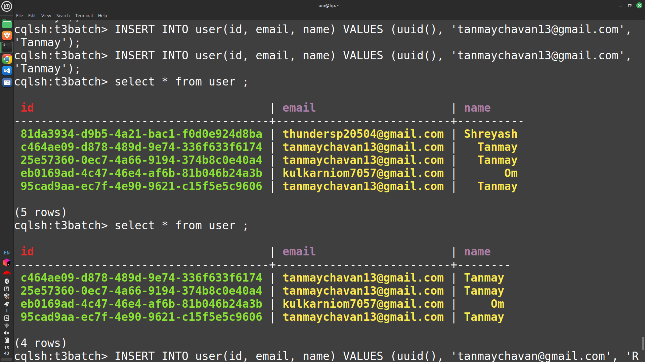
   3. 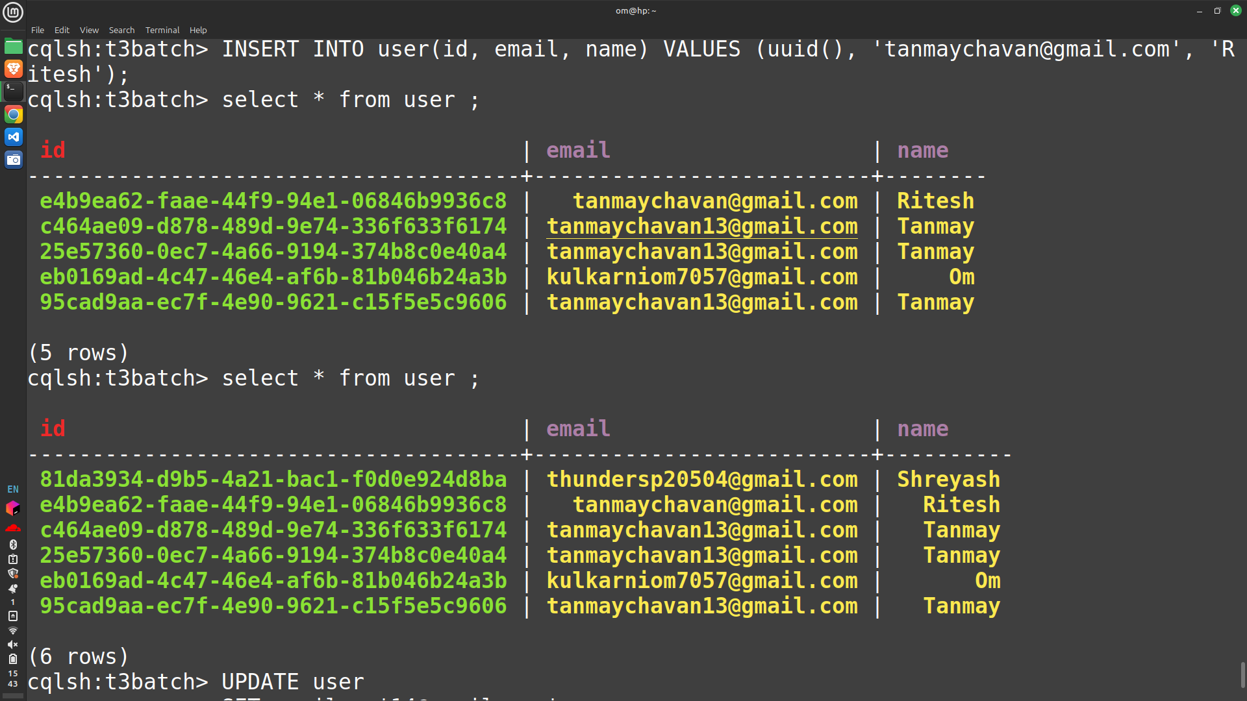
   4. 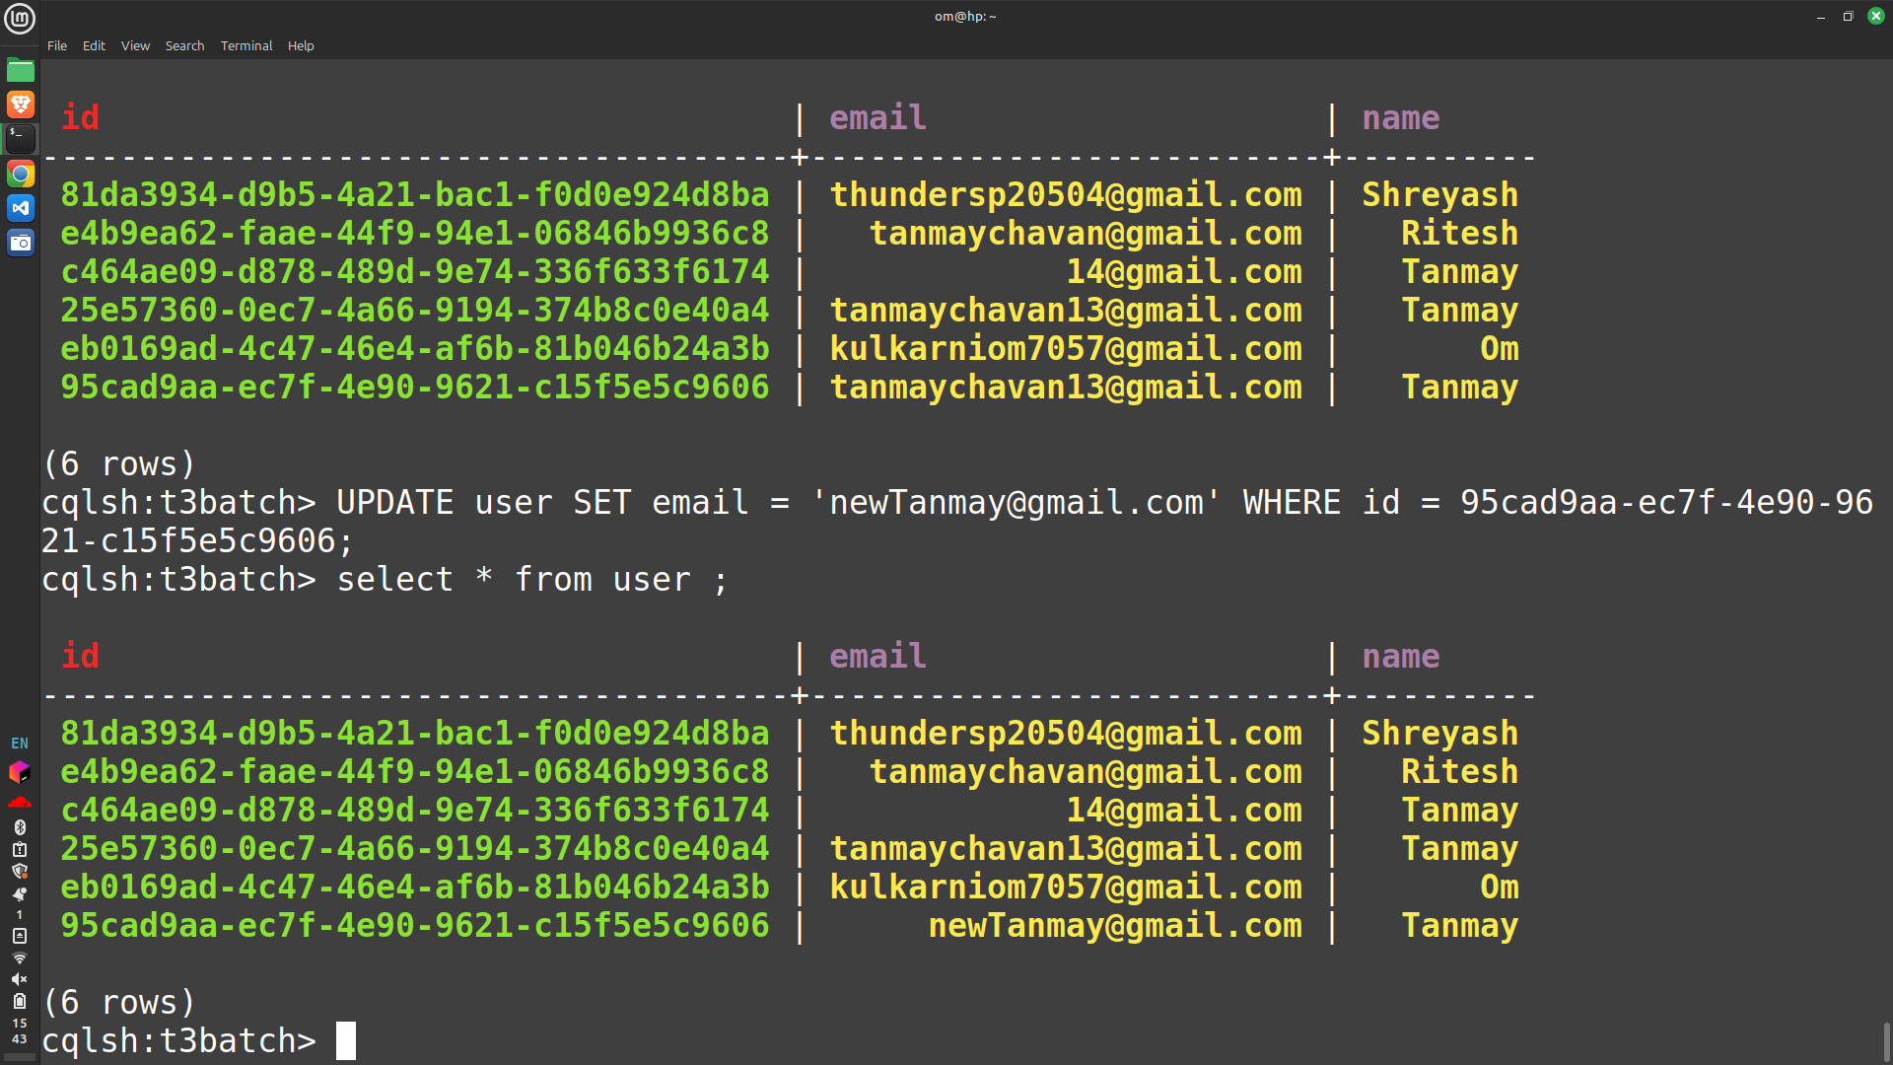
   5. 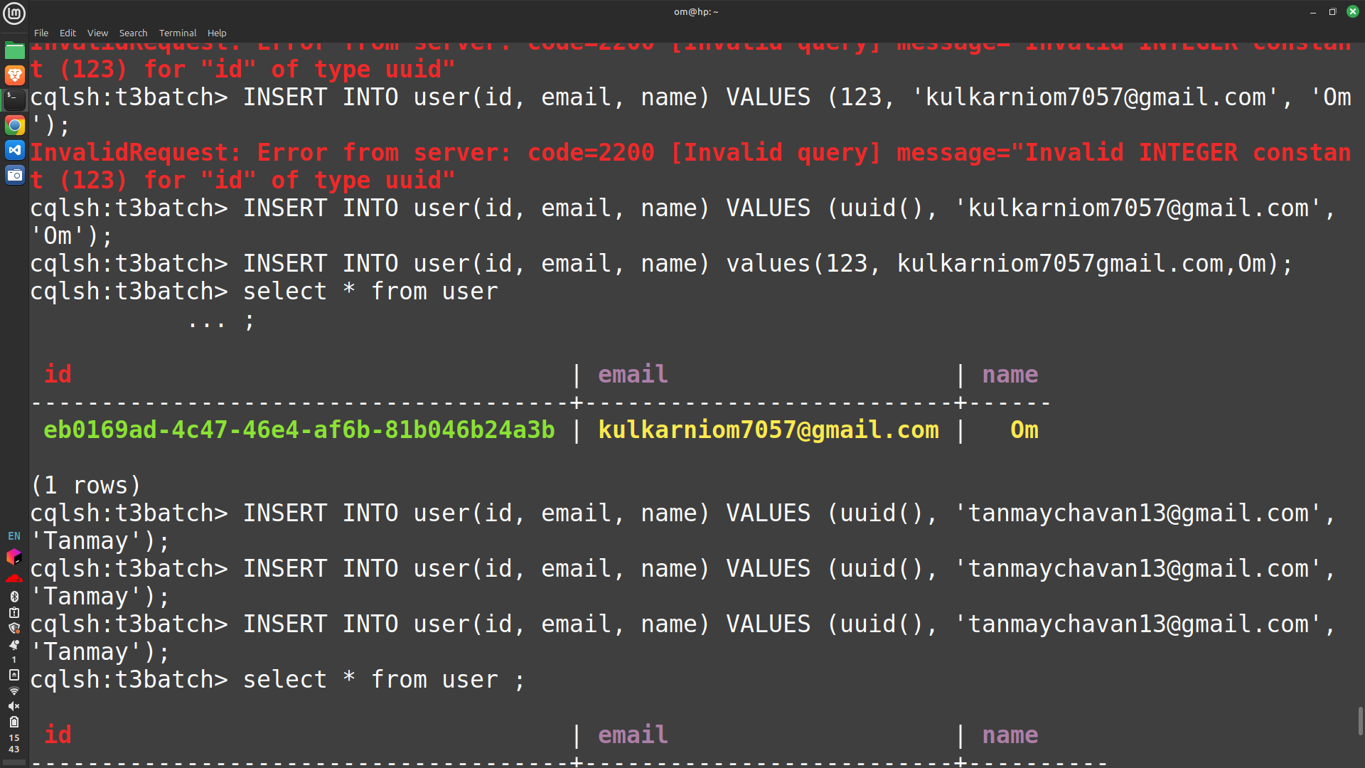
   6. 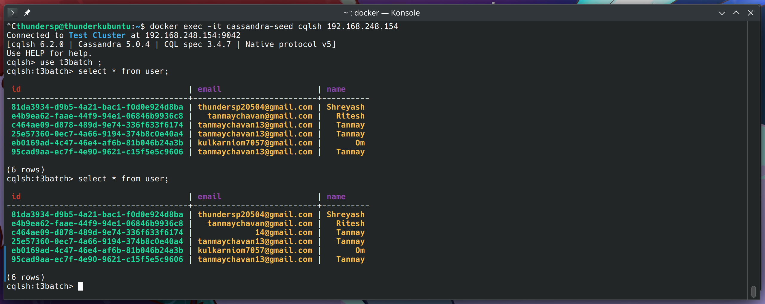
   7. 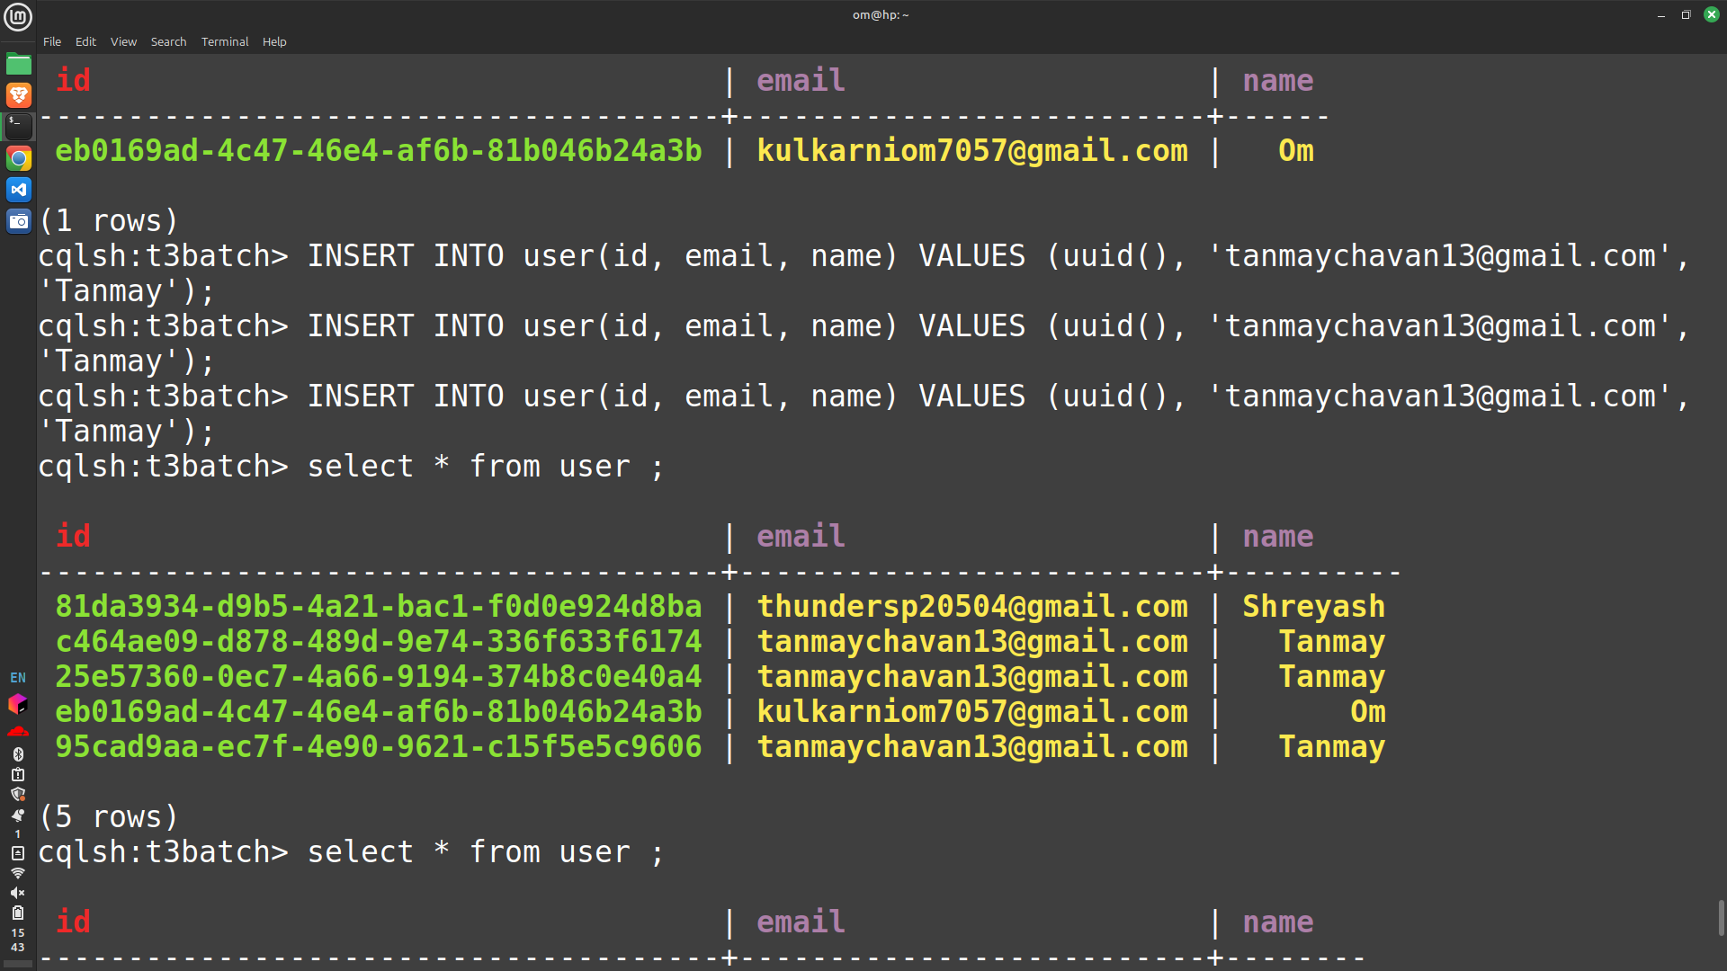
10. Even if one node goes down, the other takes over, processing the queries till the nodes come back together, no data is lost.